Hands-on 1: Create a Spring Web Project using Maven

Objective
Create a Spring Boot project using Spring Initializr, import it into Eclipse, manage dependencies using Maven, and verify successful execution.

Software Requirements
- Eclipse IDE
- Java 21
- Maven
- Spring Boot 3.x

Steps Performed
- Opened https://start.spring.io.
- Selected Maven Project and Java.
- Entered Group as com.cognizant and Artifact as spring-learn.
- Added Spring Web and Spring Boot DevTools dependencies.
- Generated and extracted the project.
- Imported the project into Eclipse.
- Allowed Maven to download dependencies.
- Updated SpringLearnApplication1.java with logging.
- Ran the application successfully.

Dependency:
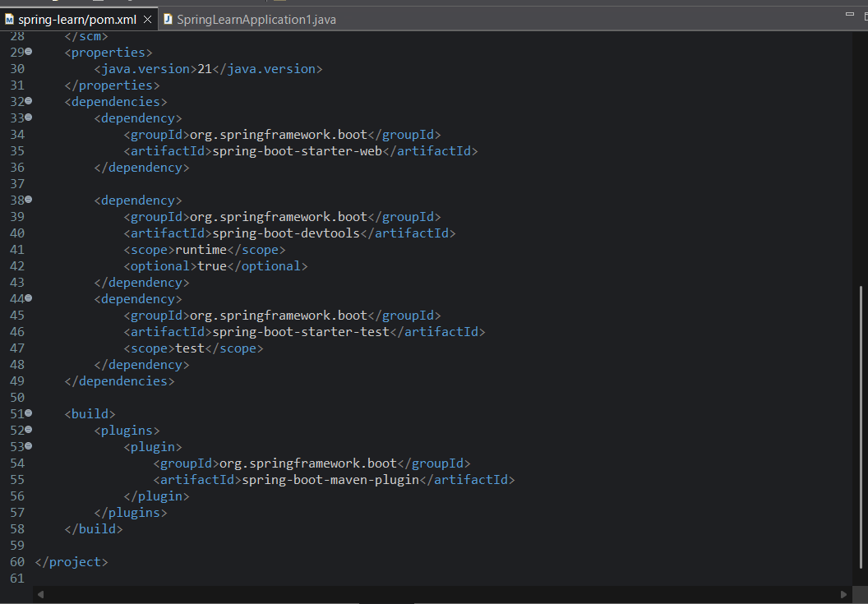

SpringLearnApplication1.java:
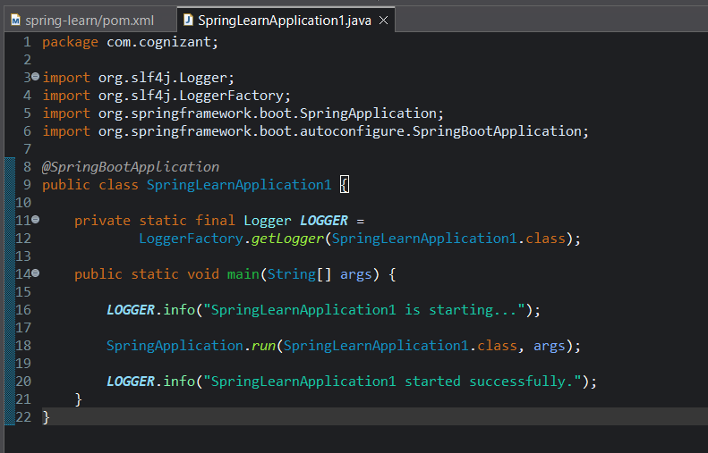

Project Structure:
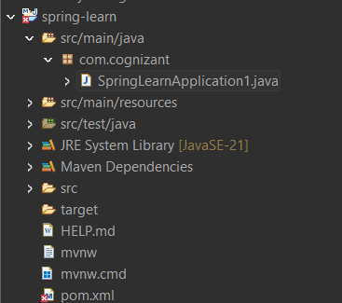

Explanation
src/main/java contains application code.
src/main/resources contains configuration files.
src/test/java contains test classes.
@SpringBootApplication enables auto-configuration, component scanning and configuration.
pom.xml manages project dependencies and build configuration.

Output:
